**Practice-1**

**Aim: WAP to demonstrate example of default constructor or no argument constructor.**

**Promgram:**

#include<iostream>

using namespace std;

class Classroom

{

public :

char cls_name[100];

//default constructor

Classroom()

{

cout << "------------------------------------------------------" << endl ;

cout << "Enter Class Name: " ; cin >>this->cls_name;

}

void getclassroom()

{

cout << "Class name is: " << this->cls_name << endl;

}

};

int main()

{

Classroom c1;

Classroom c2;

cout << "------------------------------------------------------" << endl ;

cout << "------------------------------------------------------" << endl ;

cout << "------------------------------------------------------" << endl ;

c1.getclassroom();

c2.getclassroom();

return 0;

}

**Output:**

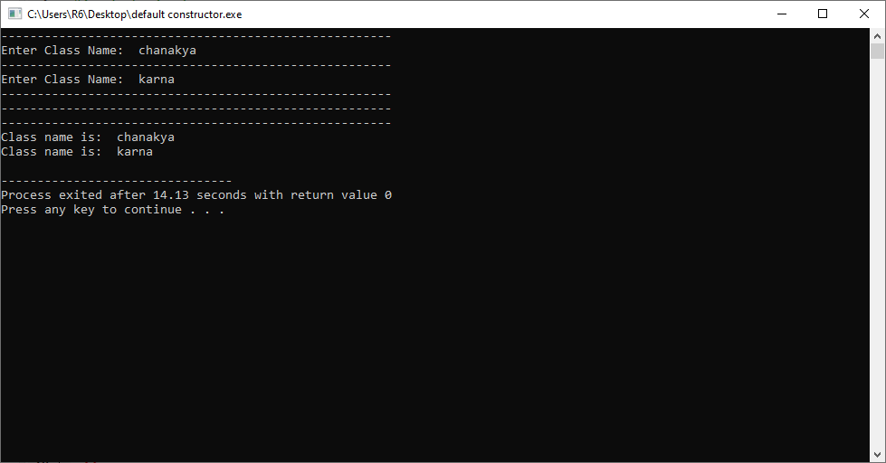

**Practice-2**

**Aim:WAP to demonstrate example of parameterized constructor.**

**Promgram:**

#include<iostream>

#include<string.h>

using namespace std;

class Classroom

{

private:

char name[100];

char course_name[100];

public:

// perameterised constructor

Classroom(char name[100],char course_name[100])

{

strcpy(this->name,name);

strcpy(this->course_name,course_name);

}

getdata()

{

cout << "Name is : " <<this->name <<", and course name is : "<<this->course_name<<endl;

}

};

int main()

{

Classroom c1("hardik","flutter");

Classroom c2("nevin","dart");

Classroom c3("vraj","ios");

c1.getdata();

c2.getdata();

c3.getdata();

return 0;

}

**Output:**

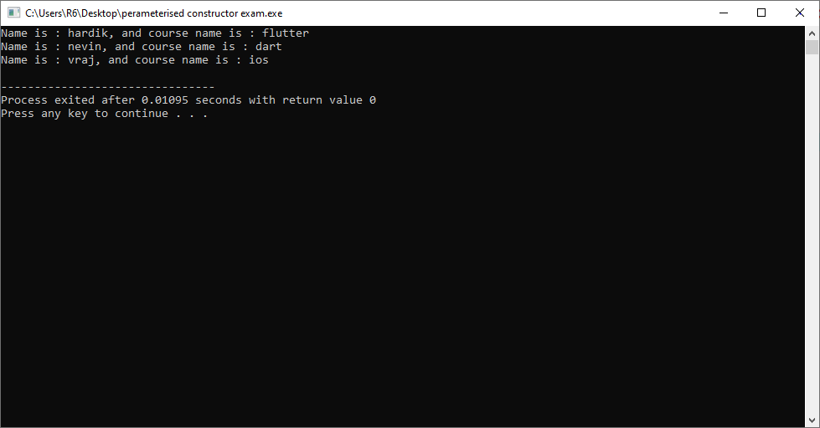

**Practice-3**

**Aim:WAP to create a class which Set values of data members using default and parameterized constructor.**

**Promgram:**

#include<iostream>

#include<string.h>

using namespace std;

class Classroom

{

private:

char name[100];

char course_name[100];

public:

// perameterised constructor

Classroom(char name[100],char course_name[100])

{

strcpy(this->name,name);

strcpy(this->course_name,course_name);

}

//default constructor

Classroom()

{

}

getdata()

{

cout << "Name is : " <<this->name <<", and course name is : "<<this->course_name<<endl;

}

};

int main()

{

Classroom c1("hardik","flutter");

Classroom c2("nevin","dart");

Classroom c3;

c1.getdata();

c2.getdata();

c3.getdata();

return 0;

}

**Output:**

